|  |  |  |
| --- | --- | --- |
| **CL-1001 Programming Fundamentals** | **LAB - 09**  **Functions and Strings** | |
| **NATIONAL UNIVERSITY OF COMPUTER AND EMERGING SCIENCES**  **Fall 2022** | |  |

**LAB 09**

In c, we can divide a large program into the basic building blocks known as function. The function contains the set of programming statements enclosed by {}. In other words, we can say that the collection of functions creates a program. The function is also known as procedure or subroutine in other programming languages.

**TYPES OF FUNCTIONS IN C PROGRAMMING**

Depending on whether a function is defined by the user or already included in C compilers, there are two types of functions in C programming

1. [Standard library functions](https://www.programiz.com/c-programming/library-function)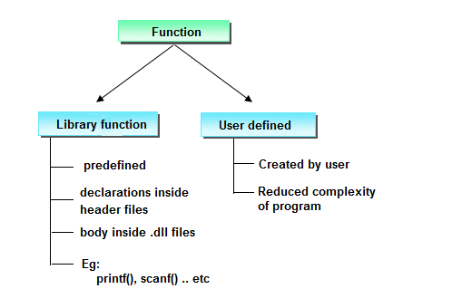
2. [User defined functions](https://www.programiz.com/c-programming/c-user-defined-functions)

|  |  |
| --- | --- |
| Functions Name | Description |
| Printf() | Print data |
| Scanf() | Read data |
| Getchar() | Read a single a character |
| Sqrt() | Calculate the square |
| Pow() | Calculate the power |
| Fopen() | Open the specified file |
|  |  |

**BENEFITS OF USING FUNCTIONS**

1. It provides modularity to your program's structure.

2. It makes your code reusable. You just have to call the function by its name to use it, wherever required.

3. In case of large programs with thousands of code lines, debugging and editing becomes easier if you use functions.

4. It makes the program more readable and easy to understand.

**HOW USER-DEFINED FUNCTION WORKS?**

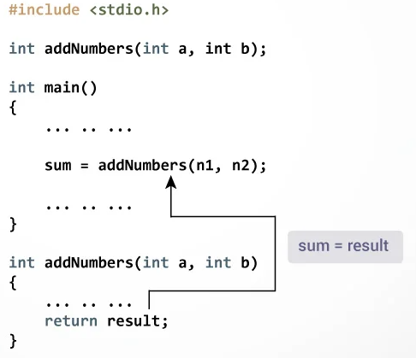

**Example: User-**



***Here is an example one to print “Hello pf- students”. To perform this task, a user-defined function printName () is defined.***



***Here is an example two to add two integer numbers. To perform this task, a user-defined function sum () is defined.***



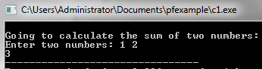

**FUNCTION PROTOTYPE**

A function prototype is simply the declaration of a function that specifies function's name,

Parameters and return type. It doesn't contain function body.

A function prototype gives information to the compiler that the function may later be used in the program.

**SYNTAX OF FUNCTION PROTOTYPE**

***returnType functionName (type1 argument1, type2 argument2,...);***

In the above example, int sum(int a, int b); is the function prototype which provides following information to the compiler:

1. name of the function is addNumbers()

2. return type of the function is int

3. two arguments of type int are passed to the function

The function prototype is not needed if the user-defined function is defined before the main() function.

**CALLING A FUNCTION**

Control of the program is transferred to the user-defined function by calling it.

**SYNTAX OF FUNCTION CALL**

***functionName (argument1, argument2, ...);***

In the above example, function call is made using sum(n1,n2); statement inside the main().

**FUNCTION DEFINITION**

Function definition contains the block of code to perform a specific task i.e. in this case, adding two numbers and returning it.

**SYNTAX OF FUNCTION DEFINITION**

returnType functionName(type1 argument1, type2 argument2,

***{***

***//body of the function***

***}***

When a function is called, the control of the program is transferred to the function definition. And, the compiler starts executing the codes inside the body of a function.

**PASSING ARGUMENTS TO A FUNCTION**

In programming, argument refers to the variable passed to the function. The parameters a and b accepts the passed arguments in the function definition. These arguments are called formal parameters of the function.

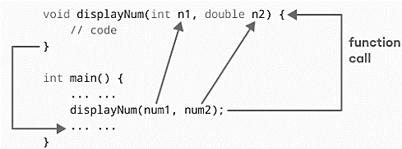

**RETURN STATEMENT**

The return statement terminates the execution of a function and returns a value to the calling function. The program control is transferred to the calling function after return statement. we have the data type int instead of void. This means that the function returns an int value.

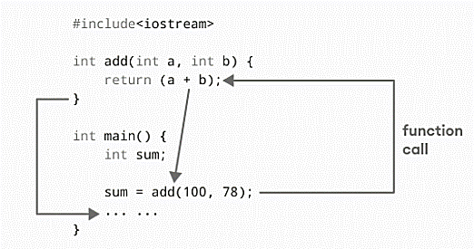

**SYNTAX OF RETURN STATEMENT**

***return (expression);***

**USER DEFINED HEADER FILE**

The purpose to understand and learn header file is that, it also contains specific function define in it. You are required to call its header and can use its defined function in your program.

Meanwhile header file serves two purposes.

* You include them in your program to supply the definitions and declarations you need to invoke system calls and libraries.
* Your own header files contain declarations for interfaces between the source files of

your program. Each time you have a group of related declarations and macro definitions

all or most of which are needed in several different source files.

***Follow the step to create your header file:***

Suppose we want to make header for sum function.

1. Make a header file with .h extension and give it unique name e.g sumfile-> sumfile.h

2. Define your program in header extension file.

a. int add(int a,int b){return(a+b);}

3. Make source file of c, where your main program is set.

a. #include<stdio.h>

b. #include "sumfile.h" // don’t use ‘<>’, instead of it use””.

c. void main()

d. { int num1 = 10, num2 = 10, num3;

e. num3 = add(num1, num2);

f. printf("Addition of Two numbers : %d", num3);}

4. Keep .h file path directory same as source file.

5. In the above program the ‘add’ function is basically called from the heder file of sumfile.h

Which we have explicitly defined.

**INTRODUCTION TO STRINGS**

* String is a series of characters treated as a single unit.
* A string may include letters, digits and various special characters such as +, -, *, / and $.
* String literals, or string constants in C are written in double quotation marks.

**STRING DECLARATION AND INITIALIZATION**

A string in C is implemented as an array, so declaring a string variable is the same as declaring an array of type **char**.

**EXAMPLE:**

char var[9] = {'F','A','S','T',' ','U','N','I'};

OR

char string_var[9] = "FAST UNI";

The variable string_var will hold strings from 0 to 8 characters long.

**NULL CHARACTER (‘\0’)**

* Null character marks the end of a string.
* All of C’s string handling functions simply ignore whatever is stored in the cells following the null character.
* When defining a character array to contain a string, the array must be large enough to store the string and its terminating null character.

**MEMORY REPRESENTATION**

|  |  |  |  |  |  |  |  |  |
| --- | --- | --- | --- | --- | --- | --- | --- | --- |
| **F** | **A** | **S** | **T** |  | **U** | **N** | **I** | **\0** |
| 0 | 1 | 2 | 3 | 4 | 5 | 6 | 7 | 8 |

**STRING INPUT/OUTPUT LIBRARY**

**INPUT/OUTPUT WITH PRINTF AND SCANF**

* A string can be read using the %s placeholder in the scanf function. However, it has a limitation that the strings entered cannot contain spaces and tabs.



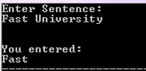

In the above code if multiple words (separated by space) are entered, scanf() will only consider the first word as shown in the output attached.

**INPUT/OUTPUT WITH GETS AND PUTS**

To overcome the problem with scanf, C provides the **gets** function. It allows us to read a line of characters (including spaces and tabs) until the newline character is entered, i. e., the Enter key is pressed. A call to this function takes the following form:

**gets(sentence);**

where, sentence is an array of char, i.e., a character string. The function reads characters entered from the keyboard until newline is entered and stores them in the argument string sentence, the newline character is read and converted to a null character (\O) before it is stored in s.

C provides another function named puts to print a string on the display. A typical call to this function takes the following form:

**puts(sentence);**

where, sentence is an array of characters, i.e., a character string. This string is printed on the display followed by a newline character.

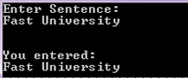

**ARRAYS OF STRINGS**

One string is an array of characters, an array of strings is a two-dimensional array of characters in which each row is one string.

An array of strings can be initialized at declaration in the following manner:

**char day[7][10] = {"Sunday" , "Monday", "Tuesday", "Wednesday", "Thursday", "Friday", "Saturday"}**

**STRINGS-FUNCTIONS**

**EXAMPLES**

**strlen function:size_t strlen(const char *str)**



**strlen vs sizeof**

**strlen** returns you the length of the string stored in an array, however **sizeof** returns the total allocated size assigned to the array. So if I consider the above example again, then the following statements would return the below values.

strlen(str1) returned value 23.

sizeof(str1) would return value 30 as the array size is 30 (see the first statement in main function).

**strcmp function: int strcmp(const char *str1, const char *str2)**

* It compares the two strings and returns an integer value.
* if Return value < 0 then it indicates str1 is less than str2.
* if Return value > 0 then it indicates str2 is less than str1.
* if Return value = 0 then it indicates str1 is equal to str2.

**#include <stdio.h>**

**#include <string.h>**

**int main () {**

**char str1[15];**

**char str2[15];**

**int ret; OUTPUT**

**strcpy(str1, "abcdef");** **str2 is less than str1**

**strcpy(str2, "ABCDEF");**

**ret = strcmp(str1, str2);**

**if(ret < 0) {**

**printf("str1 is less than str2");**

**} else if(ret > 0) {**

**printf("str2 is less than str1");**

**} else {**

**printf("str1 is equal to str2");**

**}**

**return (0);**

**SIGNIFICANCE**

**strncmp function: int strncmp(const char *str1, const char *str2, size_t n)**

It compares both the string till n characters or in other words it compares first n characters of both the strings.



**strcat function: char *strcat(char *str1, char *str2)**

It concatenates two strings and returns the combined string.

**#include <stdio.h>**

**#include <string.h>**

**int main()**

**{**

**char s1[10] = "Hello";**

**char s2[10] = "World";**

**strcat(s1,s2);**

**printf("Output string after concatenation: %s", s1);**

**return 0;**

**}**

**strncat function: char *strncat(char *str1, char *str2, int n)**

It concatenates n characters of str2 to string str1. 

**TYPICAL C PROGRAM DEVELOPMENT ENVIRONMENT**

**COMPILER VS IDE**

**IDE - Integrated Development Environment**

IDE is the software that helps to write code, provides code completion, code suggestions and other neat stuff. Therefore, Dev-C++ is an IDE and not Compiler but it lets us compile code too by using

**strcpy function: char *strcpy( char *str1, char *str2)**

It copies the string str2 into string str1, including the end character (terminator char ‘\0’).



**C - DATATYPES:**

Variables are classified according to their data type, which determines the kind of information that

**strchr function: char *strchr(char *str, int ch)**

It searches string str for character ch



**strstr function: char *strstr(char *str, char *srch_term)**

It is similar to strchr, except that it searches for string srch_term instead of a single char.

**LAB#09 EXERCISES**

|  |
| --- |
| **Task-01 -** As a programmer, you are required to create a program that takes the first and last name from a user. The program then combines both the inputs taken and prints the string backwards.  **Task-02 -** Each student is required to find out the maximum frequency of characters occurring in their name and the courses offered in Fall 2022. To find it, the student enters their name, courses offered and the program finds the maximum occurrences of a character in the name and course.  Course names should be used like Programming Fundamentals, Applied Physics, Pakistan Studies and so on.  **Task-03 -** Students are grouped in two to complete a lab task. Each student is required to enter a string of their own choice as an input to the program. The program will then display as a result whether both the strings are equal. If the strings are not equal, the program will display which of the string is greater.  Test cases:  1. Enter two strings that are same.  2. Enter two different strings.  **Task-04 -** Sales flow is one of leading software house they are starting their recruitment process for three different following positions:   1. Associate Developer 2. Assistant Developer 3. Trainee Engineer   There is defined criteria for recruitment process, if candidate clear the test with 50 marks then he will be select for the post of trainee engineer, experience are not the requirement in it. if candidate secured 60 marks with one or more than one year of experience and 70 marks with 2 year or more than two years of experience, then he/she will be select as assistant and associate developer respectively. Write a function that will take a test marks from user and ask for experience ( if its entered marks x >=60). After that, function will show the assigned position.  **Task-05 -** Write a function that prints all the unique values from a array and the number of times each value occurs. Below is an output sample. The main function takes a size of array as input and generate a random integer array with name **“array1”**. Random number limit must be between 0 and 10. The ‘main’ function call a function with the named as “Count Frequency ()”. that will find the occurrence of each value in array.    **Task-06 -** Write the program that calculate the volume  𝑉 = 𝑎 2 ∗ 1 /3 ℎ  create a two separate function   1. One function with the name of “getData (int h, int a)”, that will take two input from user for the variable of “h” and “a”. 2. Second function “volumeCalu ()” will calculate the volume and function must be called by first function “getData ()”. Only first function call from the main function.     **Task-07 -**Write a program in C to swap two numbers using function.  Test Data :  Input 1 st number : 2  Input 2 nd number : 4  Expected Output :  Before swapping: n1 = 2, n2 = 4  After swapping: n1 = 4, n2 = 2  **Task-08 -**Write a program in C to get the largest element of an array using the function.  Test Data :  Input the number of elements to be stored in the array :5  Input 5 elements in the array :  Element – 0 : 1  Element – 1 : 2  Element – 2 : 3  Element – 3 : 4  Element – 4 : 5  Expected Output :  The largest element in the array is 5.  **Task-09 -**Write a C programming to find out maximum and minimum of some values using function  which will return an array.  Test Data:  Input 5 values  25  11  35  65  20  Expected Output :  Number of values you want to input: Input 5 values  Minimum value is: 11  Maximum value is: 65 |
|  |